Kuhar Nishant, Soni Rishabh, Verma Shivam

[Email address]

Abstract

[Draw your reader in with an engaging abstract. It is typically a short summary of the document.   
When you’re ready to add your content, just click here and start typing.]

Hotel Reservation

Core Process-4

# Table of Content

1. Purpose:

2. Class Diagram

3. Sequence Diagram

4. Deployment Diagram

5. Database Diagram

6. Context Diagram

# 1. Purpose:

This document serves as the deliverable for Core Process-4 of Hotel Reservation System Project, Spring 2018. Core Process 4 marks the completion of the design phase. In this phase the models made will help design the system based on the analyzed requirements from core process 3. The deliverables included in this phase are Design Class diagram, sequence diagram, deployment diagram, context diagram and database design diagram.

# 2. Class Diagram

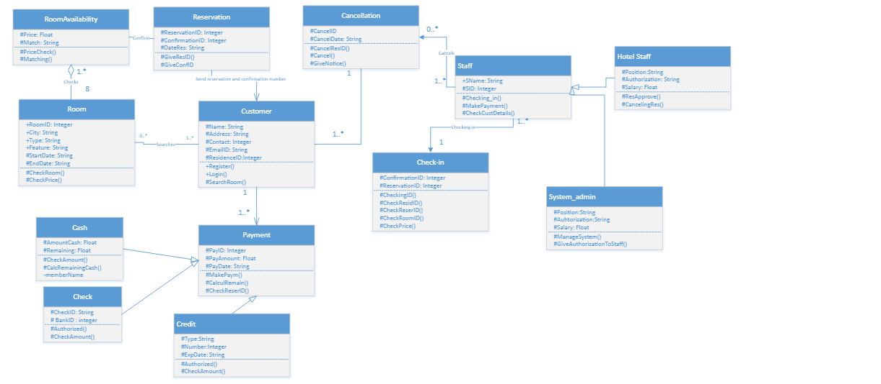

# 3. Sequence Diagram

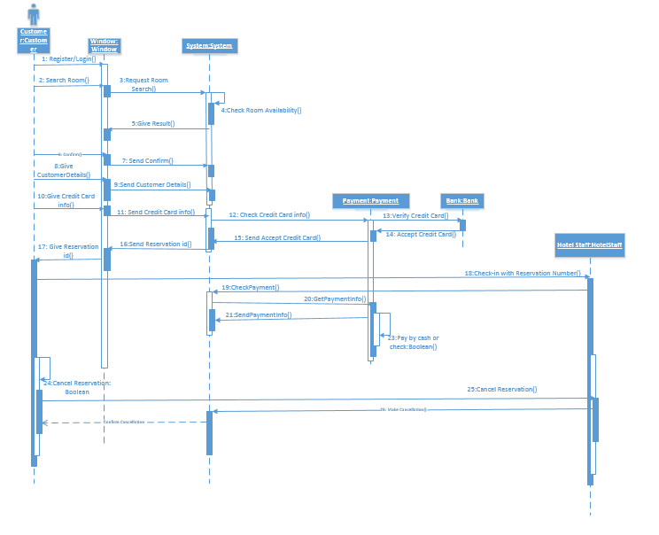

# 4. Deployment Diagram

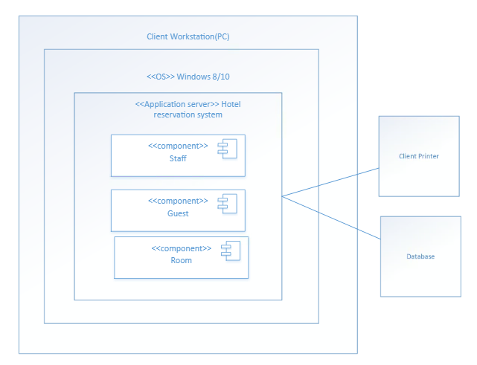

# 5. Database Diagram

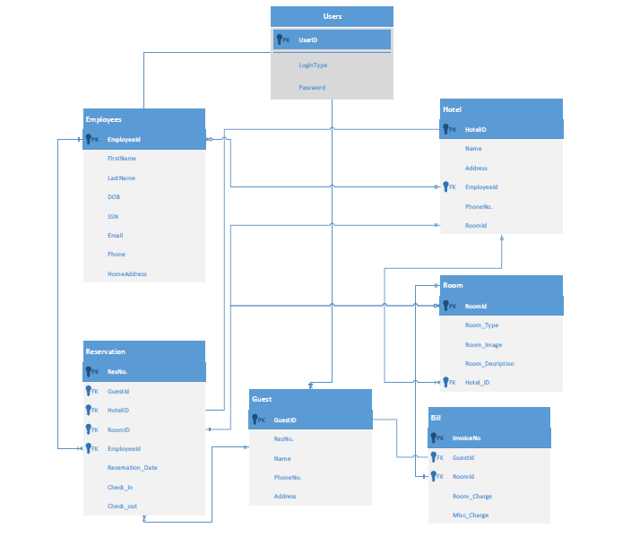

# 6. Context Diagram

